Geometry: Unit 13, Lesson 6
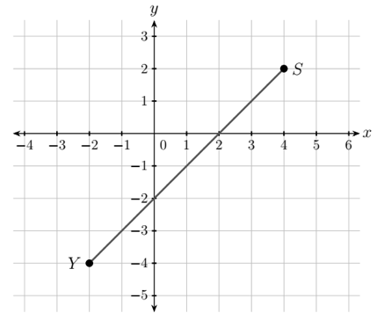
- Line segment $YS$ with endpoints at point $Y(-2, -4)$ and point $S\left(4, 2\right)$ is shown. Using the Pythagorean Theorem, what is the distance from point $Y$ to point $S$?

$$8.485$$

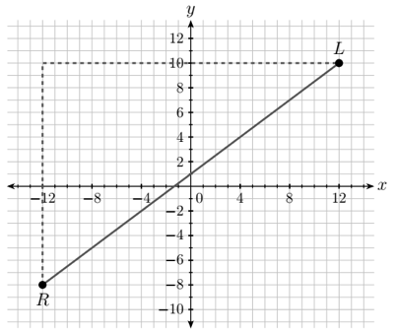

- Segment $RL$ is shown, with endpoints at point $R(-12, -8)$ and point $L(12, 10)$, What equation can be used to find the length of $\overline{RL}$?

$${24}^{2}+{18}^{2}=c^{2}$$
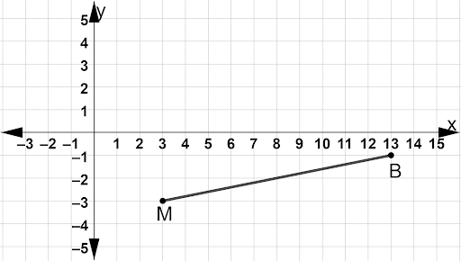
- Line segments $MB$ with endpoints at point $M\left(3, -3\right)$ and point $B(13, -1)$ is shown. Using the Pythagorean Theorem, what is the distance from point $M$ to point $B$?

$$10.198$$

